Copywriting Notes

Copywriting is the art or science of creating content that increases product awareness and persuades people to take specific actions.

The six basics of content delivery:

1. Expository – this type of content defines, clarifies, explains, or instructs.
2. Descriptive – this type of content describes, creates, and shows, often using the five senses.
3. Persuasive – this type of content persuades, convinces, coaxes, urges.
4. Narrative – this type of content comprises a story that hooks in the reader.
5. Technical – this type of content provides specifications or critical features of a product.
6. Poetic – this type of content offers brevity, density, rhythm, rhyme, and meter, as in brand slogans and taglines.

The three elements of writing according to Aristotle:

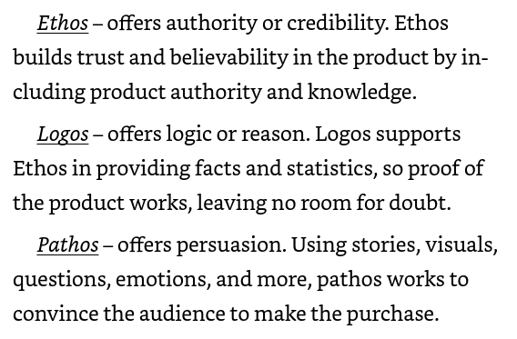

In copywriting, tone refers to the attitude, personality, or emotional tone conveyed through the writing. It's the way the writer communicates with the reader, shaping how the message is perceived and interpreted.

Tone can be:

* Formal or informal
* Friendly or professional
* Humorous or serious
* Sarcastic or genuine
* Encouraging or assertive

Effective copywriting uses a tone that resonates with the target audience, aligns with the brand's voice, and supports the message being communicated.

As in all forms of writing- know your audience by gathering demographic and cultural data to gain knowledge to help with selecting word choice and references that will best reach the audience members.

Some common tones in copywriting include:

* Conversational: like having a conversation with a friend
* Professional: polished and expert-like
* Fun: lighthearted and playful
* Empathetic: understanding and compassionate
* Urgent: creating a sense of importance or scarcity

Tone is the syntax or how you put the words together to create a particular resonance. For example:

"John Smith's gotta go. That guy uses *our* tax money to pay for *his* lavish trips, dinners with countless escorts, and meaningless golf outings. Voting for Bill Turner guarantees your money will be spent on programs that benefit our state citizens instead of satisfying one madman's selfish needs!"

Tone is created by:

1. Perspective
2. Word Choice
3. Arrangement

Use dynamic or action verbs to convey tone. Some examples may be:

* Discover
* Energize
* Ignite

When choosing words for copywrite, consider the voice of the brand. For example: you may want to use words such as “fluffy”, “soft”, and “warm” if you were writing for a quilt or blanket manufacturer.

Be sure to study all available information about the product and company when copywriting. That ensures that you will present the content in a way that is consistent with the “voice” of the brand.

Adjectives modify a noun or pronoun. These help to set modulations within copywriting. Some adjective examples are:

* Big
* Delicious
* Beautiful

With copywriting, the product is the center stage with the tone adding a spotlight.

Be consistent in voice and focus when writing copywrite. The audience will lose interest, trust, and faith when deviation occurs.

Style refers to the unique tone, voice, and language used to communicate a message, engage an audience, and persuade them to take action. It's the personality behind the words, and it can make or break the effectiveness of a piece of copy. Some examples of styles are:

* Conversational: Friendly, approachable, and relatable, like a conversation with a friend
* Professional: Formal, polished, and authoritative, often used in B2B or corporate copy
* Humorous: Light-hearted, playful, and entertaining, used to grab attention and make a point
* Storytelling: Using narratives and anecdotes to connect with the reader and convey a message

Try to avoid using cliched terms and phrases in your writing. On one hand, it can sound dated. On the other, it can sound corny and the reader loses trust in the product or message about the product.

Some things to consider when approaching copy:

* Decide on the type of content to reflect the product
* Define your grammar usage as it highlights the product
* Establish your voice as it appropriately reflects the product

SEO copywriting combines keyword optimization with compelling content that drives user action. It involves knowing your audience, using relevant keywords, and writing clear, persuasive copy that resonates with them, ultimately driving conversions and achieving your goals.

Branding is like a person's overall personality, while voice is like their tone and language when they speak. Branding is an important consideration when writing copy. Some questions to consider might include:

* Why does the product exist?
* How does the product differ from the rest?
* What problems does the product solve?
* Why should people care about this product?

If your copy causes the consumer to repeatedly nod while reading when the time comes to purchase the product, the decision has already been made.

Voice is the personality of content, as in the qualities that form a company’s distinctive character. Voice is the specific way a company communicates and expresses itself. A company's voice should be consistent with its branding. Some things to consider when thinking about voice:

* Company personality – who are they and what do they stand for?
* Type of product – medical, technology, sports.
* Product design – from generic to sleek.
* Pick three words to describe the product.
* Ask yourself, “What would the product say if the product could talk?”

Products themselves may also have “personality.” In copywriting, a product's personality refers to the human-like characteristics and traits attributed to a product or brand. It's a way to give a product a distinct and relatable identity, making it more engaging and memorable to the target audience.

A product's personality can include aspects such as:

* Tone: Friendly, serious, sarcastic, or humorous
* Language: Formal, casual, playful, or professional
* Values: Adventurous, eco-friendly, innovative, or traditional
* Attitude: Confident, empathetic, or rebellious
* Emotions: Fun, caring, or bold

There are six important psychological considerations regarding persuasion. Because copywriting involves selling a product or service, persuasion is a vital consideration. These elements to consider are:

1. Reciprocity – Meaning offering something to receive something in return. Think about how freebies and discounts are offered to entice consumers.
2. Commitment – Signing up for a newsletter or committing to a trial period. This is a great way to keep people coming back for more.
3. Social proof – Refers to the use of customer testimonials, reviews, ratings, and other forms of feedback to build trust and credibility with potential customers, demonstrating that others have had positive experiences with a product or service.
4. Authority – Refers to the credibility and expertise of a brand, product, or service, established through credentials, endorsements, evidence, and confident language, to build trust and influence with the audience.
5. Liking – Refers to the principle of influencing people's behavior by creating a sense of rapport, affection, or friendship. It's based on the idea that people are more likely to say yes to those they like and trust.
6. Scarcity – When someone in high authority makes a claim that a product or service may be limited and eventually unavailable.

The standard elements of copywriting:

1. The headline grabs the reader's attention, sets the tone, and clearly communicates the main benefit or promise of the product, service, or idea, enticing the reader to read further.
2. The hook grabs attention, raises curiosity, and draws the reader in with a provocative or intriguing opening.
3. The narrative contains many vital parts including:

* Connect with the headline by reassuring the customer they’re in the right place
* Build Credibility by establishing trust and believability
* Offer incentives to keep the audience’s interest
* Establish value
* Provide proof that you can deliver what the product/service promises
* Describe the aftermath of the product/service solving the problem
* Discuss benefits of solving the problem
* Show how the product/service is unique compared to the competition
* Establish how the advantages of the product/service outweigh the cost
* Guarantee the product/service effectiveness
* Clearly state what the consumer gains and what they need to do to get that service/product
* Close by establishing a sense of urgency

One statistic suggests that 80% of people read headlines, but only 20% continue reading beyond that point. Therefore, a concise, attention grabbing, and relevant headline is important to draw readers in.

Following the headline, there are some ways to continue gaining reader interest.

* Lead with a strong quote
* Make a humorous statement or observation
* Make a promise of what the product/service seeks to accomplish
* Provide a unique vision of what the consumer can expect in the aftermath of use
* Provide and alarming statistic to motivate the consumer to action
* Ask an urgent question of the consumer to prompt action
* Propose a benefit the consumer may gain, and rely on their curiosity to keep them reading
* State a shocking fact that will compel them to action

Another vital statistic is that only 20-28 percent of written words are read, with people scanning instead. This underlines the importance of making sure content is:

* Easy to read
* Brief (14 words or less)
* Includes plenty of whitespace
* Makes use of headings and subheadings to offer quick access to information

There are several different structural formats that the above elements can be situated in.

* The inverted pyramid is a writing approach where the most important information is presented first, followed by secondary details, and finally, supporting context, in a hierarchical format, to effectively communicate key points and grab the reader's attention.

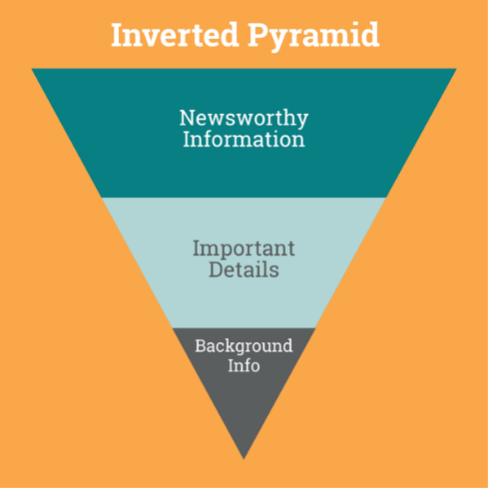

* The AIDA writing structure is a persuasive writing approach that follows a sequential format of Attention (grabbing the reader's interest), Interest (generating desire), Desire (creating a sense of need), and Action (encouraging a response or conversion).

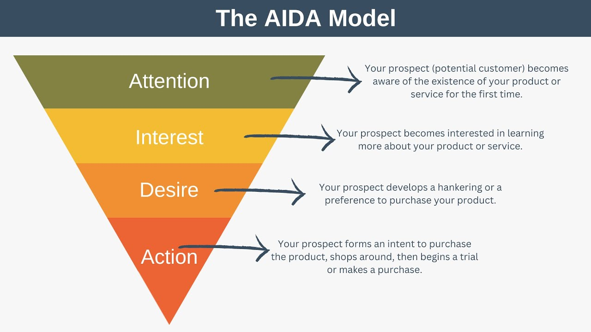

* The 4 P Copywrite formula involves considering the Product (idea or argument), Price (effort or commitment required), Promotion (messaging and communication), and Place (context and timing) to effectively influence and persuade others.

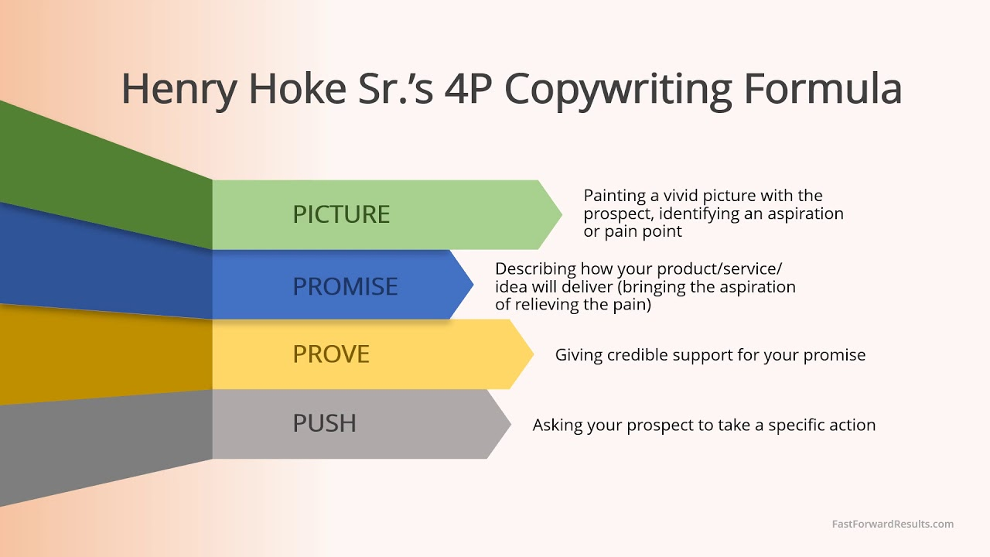

* The Before-After-Bridge (BAB) framework is a persuasive structure that presents a problem or pain point (Before), followed by a solution or vision (After), and then a bridge that connects the two, explaining how to transition from the current state to the desired outcome.

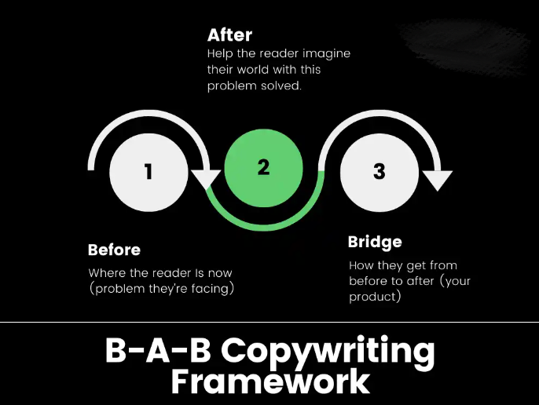

* The Identify-Agitate-Solve (IAS) framework in copywriting is a persuasive structure that identifies a problem or pain point, agitates it by emphasizing the consequences or emotions associated with it, and then offers a solution to alleviate or solve it.

